**Assignment-Neural Networks**

1. Concrete Data set:

Problem Statement- Prepare a model for strength of concrete data using Neural Networks

Soln: #apply normalization to entire data frame

concrete

concrete_norm<-as.data.frame(lapply(concrete,normalize))

#Create Training and testing data

Concrete_train<-concrete_norm[1:773,]

Concrete_test<-concrete_norm[774:1030,]

#train the neural net model

library(neuralnet)

concrete_model<-neuralnet(formula=strength~cement+slag+ash+water

+superplastic+coarseagg+fineagg+

age,data=Concrete_train)

#visualize the network topology

windows()

plot(concrete_model)

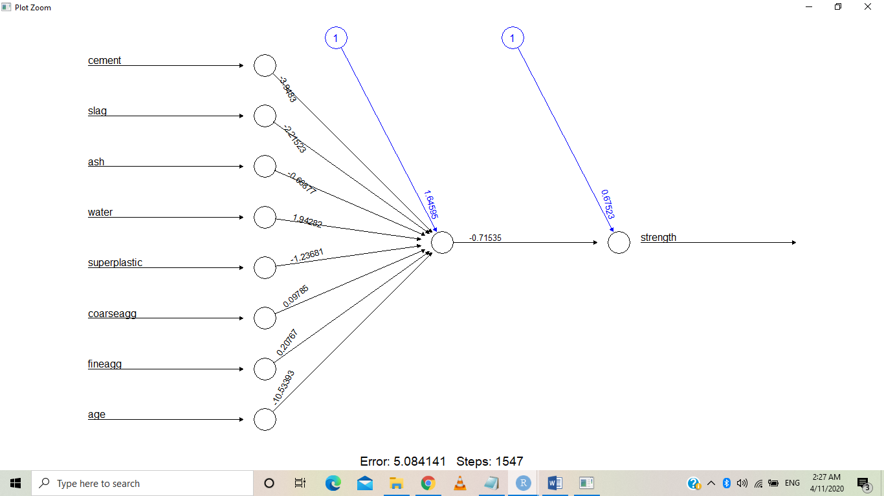

Steps: 1547

Error: 5.084

#Evaluate model Performance

model_results<-compute(concrete_model,Concrete_test[1:8])

#Obtain predicted strength values

predicted_strength<-model_results$net.result

#examine corelation between predicted and actual values

cor(predicted_strength, Concrete_test$strength)

0.8057751

80% corelateion found between predicted value and calculated value

Reiterating the model with hidden neurons for further improving model performance;

concrete_model2<-neuralnet(formula=strength~cement+slag+ash+water

+superplastic+coarseagg+fineagg+

age,data=Concrete_train,hidden=c(5,2))

plot(concrete_model2)

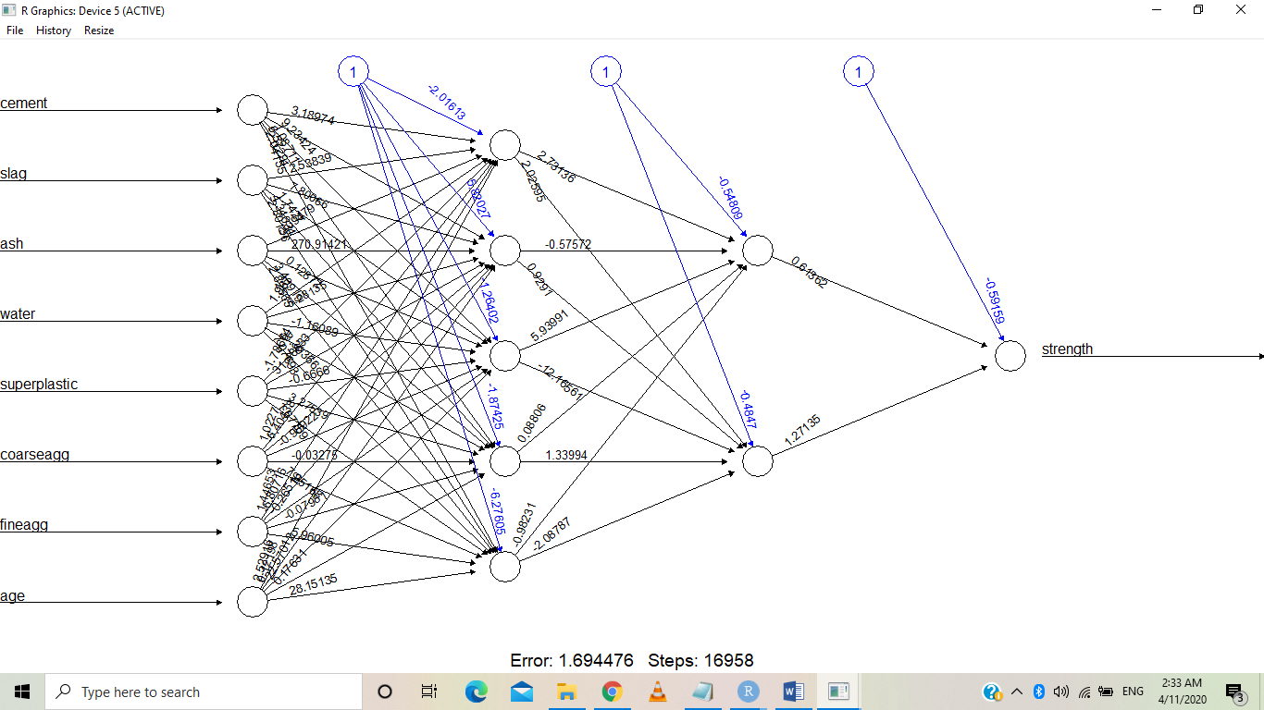

#Evaluate results as did before

model_results2<-compute(concrete_model2,concrete_test[1:8])

predicted_strength2<-model_results2$net.result

cor(predicted_strength2, concrete_test$strength)

0.9135928

Performance improved and errors reduced.

1. 50 Startups:

Problem statement: Build a Neural Network model for 50_startups data to predict profit

#50 Startups

#load the data

startup <- `50_Startups`

#creating dummy variable for "State" column

startup <-dummy_cols(startup,select_columns =='State', remove_selected_column =T)

View(startup)

#custom normalize the data

normalize <- function(x) {

return ((x - min(x))/(max(x)-min(x)))

}

startup_nl <- as.data.frame(lapply(startup[1:4], normalize))

View(startup_nl)

startup_norm <- cbind(startup_nl, startup[,c(5,6,7)])

View(startup_norm)

#creating training and testing datasets

start_train <- startup_norm[1:40,]

start_test <- startup_norm[41:50,]

#training model without hidden layers

startup_model <- neuralnet(formula = Profit ~ R.D.Spend + Administration + Marketing.Spend , data = start_train)

windows()

plot(startup_model)

#obtaining model result

startup_model_result <- compute(startup_model, start_test[c(1,2,3,5,6,7)])

#predicted strength vs actual strength

start_pred <- startup_model_result$net.result

#correlation between predicted vs actual

cor(start_pred, start_test$Profit) #75.39

#training model with hidden layers

startup_model2 <- neuralnet(formula = Profit ~ R.D.Spend + Administration + Marketing.Spend , data = start_train, hidden = c(5,3))

windows()

plot(startup_model2)

#model result

startup_model_result2 <- compute(startup_model2, start_test[,c(1,2,3,5,6,7)])

#predicted vs actual

start_pred2 <- startup_model_result2$net.result

#correlation between pedicted and actual

cor(start_pred2, start_test$Profit) #75.8

#experiments with hidden layers and feature selection

sm <- neuralnet(formula = Profit ~ R.D.Spend + Administration + Marketing.Spend , data = start_train, hidden = c(10,5))

windows()

plot(sm)

sm_result <- compute(sm, start_test[c(1,2,3,5,6,7)])

sm_pred <- sm_result$net.result

cor(sm_pred, start_test$Profit) #73.01

#increase in hidden layers has led to decrease in accuracy

#building model with a lesser hidden layer

sm2 <- neuralnet(formula = Profit ~ R.D.Spend + Administration + Marketing.Spend , data = start_train, hidden = c(3,2))

plot(sm2)

sm2_result <- compute(sm2, start_test[-4])

sm2_pred <- sm2_result$net.result

cor(sm2_pred, start_test$Profit) #74.9

sm3 <- neuralnet(formula = Profit ~ R.D.Spend + Administration + Marketing.Spend , data = start_train, hidden = c(4,1))

sm3_result <- compute(sm3, start_test[-4])

sm3_pred <- sm3_result$net.result

cor(sm3_pred, start_test$Profit) #78.79

sm4 <- neuralnet(formula = Profit ~ R.D.Spend + Administration + Marketing.Spend , data = start_train, hidden = c(6,1))

sm4_result <- compute(sm4, start_test[-4])

sm4_pred <- sm4_result$net.result

cor(sm4_pred, start_test$Profit) #79.72

1. PREDICT THE BURNED AREA OF FOREST FIRES WITH NEURAL NETWORKS

#loading the data

forestfires<-forestfires

forestfires$size_category <- as.numeric(forestfires$size_category)

ff <- forestfires[,-c(1,2)]

View(ff)

is.null(ff) #checking if the dataset has null values

#normalize the dataset

normalize <- function(x) {

return ((x - min(x))/ (max(x)-min(x)))}

ff_norm <- as.data.frame(lapply(ff, normalize))

#EDA

#scatter plot matrix

plot(ff$area, type = "l")

windows()

pairs(ff_norm)

cor(ff)

ff_eda <- ff_norm[,1:9]

##checking for multi-collinearity

install.packages("car")

library(car)

ff_mlrmod <- lm(ff_eda$area~. , data = ff_eda)

car::vif(ff_mlrmod)

pairs(ff_eda)

cor(ff_eda)

#subset selection

library(MASS)

stepAIC(ff_mlrmod)# the StepAIC value is the least at 2954.8 except MonthSep and Daywed

#creating training and testing datasets

library(C50)

library(caret)

intraining <- createDataPartition(ff_norm$area, p = 0.8, list = F)

ff_train <- ff_norm[intraining,]

ff_test <- ff_norm[-intraining,]

#building model without hidden layers

library(neuralnet)

ff_mod <- neuralnet(formula = area ~ FFMC + DMC + DC + ISI + temp + RH + wind + rain

, data = ff_train)

ff_mod <- neuralnet(formula = area ~ FFMC + DMC + DC + ISI + temp + RH + wind + rain +

dayfri + daymon + daysat + daysun + daythu + daytue + monthapr +

monthaug + monthdec + monthfeb + monthjan + monthjul + monthjun +

monthmar + monthmay + monthnov + monthoct + size_category, data = ff_train )

ff_mod_result <- compute(ff_mod, ff_test[-9])

ff_pred <- ff_mod_result$net.result

cor(ff_pred, ff_test$area)

Result: [1,] 0.4104754

